Table of Contents

CERTIFICATE………………………………………………………………………………………………………………....i
DECLARATION……………………………………………………………………………………………………………....ii
ABSTRACT…………………………………………………………………………………………………………………...iii
ACKNOWLWDGEMENT……………………………………………………………………………………………………iv

1. company profile 4
1.1. Alpha Net Technologies Pvt. Ltd 4
1.2. Some Key Facts and Numbers 5
1.3. The Alpha Net Strength 6
1.4. The Alpha Net Core Competencies 7
1.5. Our Prestigious Clients 8
1.6. Current Projects 9
2. java technology 13
2.1. The Java Programming Language 13
2.2. The Java Platform 15
2.3. Exception Handling 16
2.4. Multithreading 18
2.5. Collections Framework 19
2.6. JDBC 21
2.6.1. JDBC Architecture 22
2.6.2. JDBC Components 24
2.6.3. JDBC Drivers 26
2.7. Remote Method Invocation 27
2.7.1. RMI Architecture 27
2.7.2. RMI Architecture Layers 28
2.7.3. Using RMI 29
3. software & other technologies 30
3.1. J2SE – Java 2 Standard Edition 30
3.2. J2EE – Java 2 Enterprise Edition 31
3.3. J2ME – Java 2 Micro Edition 32
3.4. Web Components 33
3.5. Business Components 34
3.6. Java EE 5 APIs 35
3.6.1. Enterprise JavaBeans Technology 35
3.6.2. Java Servlet Technology 36
3.6.3. JavaServer Pages Technology 36
3.6.4. JavaServer Pages Standard Tag Library 36
3.6.5. Java Message Service API 37
3.6.6. JavaMail API 37
3.6.7. Java Database Connectivity API 37
3.7. NetBeans 38
3.7.1. NetBeans – Developing Windows Application 38
3.7.2. NetBeans – Developing Web Application, Enterprise Application and Web Service 39
3.8. GlassFish 40
3.9. Apache Tomcat 41
3.10. MySQL Database Server 42
4. web interface 44
4.1. HTML 44
4.2. XML 45
4.3. XHTML 46
4.4. CSS 47
4.4.1. CSS provides means to customize inbuilt HTML tags 47
4.4.2. Multiple Styles Will Cascade Into One 48
4.5. JavaScript 49
4.5.1. A few words about JavaScript 49
4.5.2. Purpose of using JavaScript 49
5. software life cycle model 50
5.1. Different phases of the classical waterfall model 50
5.2. Feasibility Study 51
5.3. Requirements Analysis and Specification 52
5.4. Design 53
5.5. Coding and Unit Testing 53
5.6. Integration and System Testing 54
5.7. Maintenance 54
6. Project - WebDriveExplorer 55
6.1. Software Requirement Specification 55
6.1.1. Overview 55
6.1.2. Current System 56
6.1.3. Business Functions Provided in Proposed System 57
6.1.4. Input Requirements of the System 57
6.1.5. Output Requirements of the System 57
6.1.6. Special User Requirements 58
6.1.7. Modules 58
6.1.8. Users of the System 58
6.1.9. Technologies to be used 59
6.1.10. Software Requirements 60
6.1.11. Hardware Requirements 60
6.2. Data Model 61
6.3. Data Flow Diagrams 63
6.3.1. Trail Request Maintenance 63
6.3.2. Approve User on Trial 64
6.3.3. Web Drive Plan Maintenance 65
6.3.4. Profile Management 66
6.3.5. Manage Web Drive 67
6.3.6. Share Files 68
6.3.7. View Shared Files 69
6.4. Screen Layouts 70
6.4.1. Login 70
6.4.2. Manage WebDrive Plan 71
6.4.3. Trial Request Maintenance 72
6.4.4. Manage All Files 73
6.4.5. View Recent Activities 74
6.4.6. Upload File 75
6.4.7. Create Folder 76
6.4.8. Share Files 76
6.4.9. Show Starred Files 77

company profile

Alpha Net Technologies Pvt. Ltd
Alpha Net is a global provider of technology services enabling clients to reach their business goals.
Alpha Net is a global software consulting and application development company specialized in tackling the most complex business problems through the use of technology, maximizing investment performance across portfolio of business critical applications, while reducing time and risk, since 1999.

Alpha Net currently has development centers in Santa Clara, CA, US and Chandigarh, India. The Alpha Net's development centers are state-of-the-art facilities in terms of their infrastructure, data security, and physical location projection. The development centers have IT infrastructures that span from Open Systems environments like Linux to the latest Windows-based systems. The centers have high-speed data links that connect them with each other and with the clients to create seamless virtual teams. Since we know security is important to you, the networks are protected through multiple layers of firewalls and DMZ implementations to ensure our customers' assets are protected.

Some Key Facts and Numbers
~ | Current company is in State of California, United States of America.
~ | Parent Company founded in State of New York, United States of America in Dec 1999
~ | Indian Operations started in Dec 2003.
~ | Current Gross Revenues of company are 7 Million USD.
~ | Total employee strength in USA and India: 75
~ | Awarded “Small Business Specialist” certification from Microsoft Corporation
~ | Tie up with Chandigarh Engineering College (CEC), Landran to automate its all processes due to the demand of modern era.
~ | Memorandum of Understanding (MoU) with Chandigarh Engineering College (CEC), Landran to provide training and placements of its students from MCA, CSE and other IT disciplines.
~ | Organize all events in Chitkara Institute of Engineering and Technology (CIET), Rajpura, Chandigarh in the years 2008 & 2009.
~ | Memorandum of Understanding (MoU) with Chandigarh College of Engineering and Technology (CCET), Chandigarh for consultancy projects.
~ | Placement for brilliant student(s) from the training to the company and after certain period of time according to their performance shifts them to the US office on H1B/L1B Visa.

The Alpha Net Strength
~ People focused on personal growth and continuous learning
~ Commitment to excellence
~ Rapid response to your needs
~ process orientation & strict adherence to development methodologies
~ Timely adoption & assimilation of technologies
~ Collaborative business model
~ Flexibility in development model
~ Honest, open and ethical relationships with all

We provide expertise in the following areas:

Staff Augmentation: Alpha Net Staff Augmentation provides a short and long term solution for organizations the need help managing the people, processes and technologies that deliver and sustain value in the complex IT implementation environment. Often organizations have projects that require the focus of key resources; Alpha Net Staff Augmentation can assist these organizations on a project specific basis to ensure projects are completed on schedule. Alpha Net Staff Augmentation matches experienced IT professionals and internal staff to create a powerful team that support development while saving organizations the time and money of developing such teams in-house.

Risk sharing projects: Alpha Net risk sharing services provides a short and long term solution for organizations that need help implementing advanced technologies and like to manage their people & processes. Since Information technology is intended to help our clients become more effective in their business operations. We are open to linking our charges for a project with the level of business benefit our clients realize or assist clients on a project by assuming + & - % risk to ensure projects are completed on scheduled time & cost.

Fixed bid projects: Our 'fixed bid' projects model provides the framework for a win-win scenario, in which the client is assured of quality deliverables within budget, on schedule. At the same time, we are assured of rewards for successful and on-time delivery of the assigned task. Clients also have the flexibility to choose a transaction-based model, where they pay us as and when realize revenues and is linked to the volume of transaction handled by the system we develop.

Time & Material projects: Our clients can utilize the services of our highly qualified resources on time and material assignments for consulting. We offer time and material services for both onsite as well as offshore assignments. In such engagements, the client has complete flexibility in working with our Associate and engaging them in tasks that match their expertise.

The Alpha Net Core Competencies
Our multiple process models address specific customer and project needs and span Domain Service, Maintenance, Testing, Conversion and Development process models.
We build personal relationships with our staff to understand their goals, and we leverage their strengths to improve the services they provide. We pride ourselves to be the Agile & Flexible solution delivery provider. Alpha Net & our developers could provide services in most flexible environments.

Consulting and Implementation: Consulting and Implementation services in ERP domain (primarily in SAP R/3 and Oracle Applications) and advances Internet technologies i.e. Microsoft .NET, J2EE framework and open technologies like Ruby, PHP, Python, etc.

Content Development and Technical Writing: We have written multiple technical books for our US Clients. Some of the books which we have written and are being used in training for US companies are:
~ OOP Programming using Java
~ J2EE Programming
~ Introduction to Struts
~ .NET framework
~ ASP.NET
~ XML
~ Web services

Enterprise Application Development: We are developing Web solutions for complex integration issues between ERP and legacy systems. We are involved in multiple offshore projects for developing Enterprise Applications using Java and .NET technologies. Alpha Net specializes is providing tailor-made outsourcing solutions for development and maintenance of your non-core business requirements using reliable, secure and agile infrastructure & resources

Training in Advanced Technologies: Training in Advanced technologies: Shortage of skilled manpower prompted us to open Training division to cater to our company needs and for outside world as well. Our training division is providing training in following streams:
Enterprise Application development using Java & DOTNET Technologies
Mobile Application development using Java & DOTNET Technologies
Web Application development using Java, DOTNET & PHP
Games development using C++, C#, Java
Hardware interfacing development using C, C++, VC++
Device Driver development using Assembly Language
Embedded Devices design and development using Assembly Language and C.

Our Prestigious Clients
List below includes our partial client base.
Wells Fargo Bank
Cisco
VMware Inc
DuPont
International Paper
Solyndra Inc
Autodesk Inc.
Applied Materials
Silicon Graphics Inc
Gold Bank
Sappi Fine Paper
Sinai Medical Center
IBM
Adaptec Inc
Landmark Education Corporation
Form Factor Inc
Tran bay Cable
Steel River Infrastructure Partners
Transcontinental Media Group
Ready touch Inc
Nextg Networks
Novartis
Biomed Systems Inc
Showmypc.com
NEC

Current Projects
Biomed LIMS (Laboratory Information Management System) – Biomed LIMS is an Enterprise Application that provides the functionality to manage all the processes of a Medical Laboratory. The basic idea behind the application is to manage Patient’s Demographic & Medical Information, create Requisitions, manage Specimens using Barcodes, Test Report & Bills Automation, inform the Patient’s Physician using FAX or Email, maintains the patient Accession History and also generate graphical Test Reports for analysis.

Eye24By7 – It is a product to provide the complete Surveillance solutions. It provides the tools that communicate with IPCameras to display live feed. Provision of saving the live feed will also be provided in this system. Eye24By7 is intended to target private or government organizations, schools, colleges, hospitals etc. Eye24By7 customers will be able to centralize and automate their surveillance. Tools will be developed for customers using which customers would be able to:
Test IP Camera installed on their premises.
View & Save videos by capturing live feed coming from IPCamera.
Upload the saved videos to a central repository.
View saved video on web pages.

CSRPP – Central Seniority Recasting of Punjab Police CSRPP application has specially designed interfaces for navigational purposes and sophisticated formulas for generating powerful results. The application is divided into two modules; one module is designed for gathering data (service particulars of officers) from various units of Punjab Police scattered in whole Punjab. The data entry can be done online as well as offline by the various units using CSRPP. The second module is the core part of application, which is designed for recasting the central seniority of various officers on the basis of seniority criteria of Punjab Police Act & the data gathered from all units of Punjab Police.

Online CIMS (Online Current Index of Medical Specialties) – It is an application which will keep a large knowledge base of medicines. The main objective behind the application to develop a search engine which allow users to look around the medicines available in the market containing specific salt. Application is intended to target the general public like pharmaceutical companies, physicians, chemists and patients, who are concerned with medicines in any way.

Fin Tech – Fin Tech is EDPA (Electronics Device Production Automation) company. It has its own Research & Development division and also Production division to design and develop Electronics Circuits. To maintain information of their clients all over the world, maintain information of all products developed by them and automate their internal processes, an Enterprise Application will be developed using Java Technologies. The main objective of this application is to provide an interface for the users using which they can get the information regarding the different electronic devices

Alphanizer – It is a social networking based web application intended to be a meeting place for users from various backgrounds, cultures and with different characteristics. It helps people to maintain existing relationships and develop new ones with other users who share same hobbies and interests. 'Alphanizer' proves to be a platform for users to share their photos, videos and music files with their friends, acquaintances and just about anybody with internet connectivity.

TRMgr (Technical Resource Manager) – TRMgr is an enterprise application that will provide a web interface for technical resources to learn java programming. The resources are WebIDE and Online Java API Documentation. WebIDE is a powerful online programming environment for java programming. It provides an online environment to the users where they can develop, compile and run their java programs without the installation of any java specific softwares and doesn't require any path settings. Online Java API Documentation will provide online documentation for methods of the classes and interfaces in Java API with examples using which the users can easily learn the use Java API specific classes and interfaces.

E Organization – It is an enterprise application to automate all the processes of an educational organization like engineering colleges. The goal of the application is to keep track of all the things whether they are tangible or intangible, which are coming inside the organization or going outside of the organization, which makes the scope of application vast. E Organization is the role based application. Different designations of the organization are provided with different access rights.

Enterprise Resource Planning (ERP) System – The ERP system would cater to the requirements in the area of Sales, order and invoicing, production planning, production, inventory, purchase, finance, personnel and payroll management.

Shipping Manager – Web based communication between ERP and non ERP systems.

Document Management System – The system helps in scanning, optical character recognition (OCR), and indexing of between 2 million and 12 million pages of tobacco industry documents. The system then helps in document search, retrieval, indexing, workflow management and distribution.

Titan 3000 – Accounts Receivable Module – Titan 3000 is a fully integrated business solution for the perishable goods industry. The system is broken into the modules such as: Customer Service, Loader, Route Accounting, Accounts Receivable, Commissions, Sales Analysis, Production, Inventory Control, Purchasing and Receiving, Accounts Payable, Cost Accounting, General ledger, External Data Devices (hand-held computers), and a Custom Report Writer.

Web Drive – Web Drive would be a web Product that will provide a common platform for storing and sharing data online. Web Drive is basically, the ability to store and share data in the form of files on the Internet. The data stored on a Web Drive can be accessed using a web browser (rather than directly like on a network drive).

Memories Bucket – Share Memorable Pictures Memories Bucket, is a web based application and is intended to offer creative online photo sharing solutions for allowing the users to organize their captured memories and make them presentable to all the friends in a group. It allows the registered user to make customized album by uploading specific photos. The album created by the user can be private as well as shared. The end user is provided with a user friendly interface to create/manage group(s) for maintaining friends for sharing images with specific rights. It provides a smooth, intuitive interface for the user to create fascinating layouts by selecting background themes and by applying the different attractive themes provided by the application. The registered user can find his/her friends who are already registered with Memories Bucket. He/she is also allowed to invite new friends to join Memories Bucket. User can comment on the photographs which are available for viewing. The application also provides a smart tool (windows application), which allows the registered users to manage the pictures/albums without using web application.

a2zwireless – a2zwireless is a web application provides the online mobile shop to the users. Company has integrated the Search and Comparison module to provide the user with extensive search capability on the basis of pre defined search parameters. User can compare features of different phones.

Web Mailer – Web Mailer is a web Product that can be integrated in any web application for sending mass emails. Web Mailer is for the usage in professional environment that’s why Web Mailer provides the capability of customizing a mail that is to be sent to a number of recipients. It will also provide the capability of customizing a mail with a help of a template or user can create his/her own template for the mail. Web Mailer will also provide the capability of saving a mail in to drafts so that a user can start from where he left.

java technology

Java technology is both a programming language and a platform.

The Java Programming Language
The Java programming language is a high-level language that can be characterized by all of the following characteristics
Simple
Object oriented
Distributed
Multithreaded
Architecture neutral
Portable
High performance
Robust

In the Java programming language, all source code is first written in plain text files ending with the .java extension. Those source files are then compiled into .class files by the javac compiler. A .class file does not contain code that is native to your processor; it instead contains bytecodes — the machine language of the Java Virtual Machine¹ (Java VM). The java launcher tool then runs your application with an instance of the Java Virtual Machine.

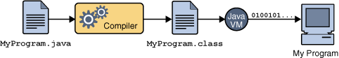
Figure 2-1 An overview of the software development process
Because the Java VM is available on many different operating systems, the same .class files are capable of running on Microsoft Windows, the Solaris TM Operating System (Solaris OS), Linux, or Mac OS. Some virtual machines, such as the Java HotSpot virtual machine, perform additional steps at runtime to give your application a performance boost. This include various tasks such as finding performance bottlenecks and recompiling (to native code) frequently used sections of code.

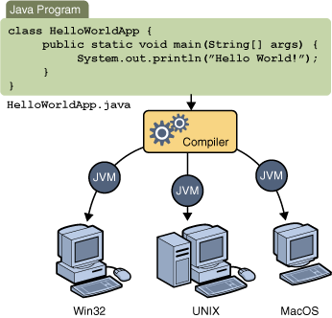
Figure 2-2 Same application running on multiple platforms

Through the Java VM, the same application is capable of running on multiple platforms.

The Java Platform
A platform is the hardware or software environment in which a program runs. Most platforms can be described as a combination of the operating system and underlying hardware. The Java platform differs from most other platforms in that it's a software-only platform that runs on top of other hardware-based platforms.

The Java platform has two components:
The Java Virtual Machine
The Java Application Programming Interface (API)

Java Virtual Machine is the base for the Java platform and is ported onto various hardware-based platforms.
The API is a large collection of ready-made software components that provide many useful capabilities. It is grouped into libraries of related classes and interfaces; these libraries are known as packages.
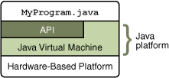
Figure 2-3 Java Platform

The API and Java Virtual Machine insulate the program from the underlying hardware.
Every full implementation of the Java platform gives you the following features:
Development Tools: The development tools provide means for compiling, running, debugging, and documenting your applications. The main tools are the javac compiler, the java launcher, and the javadoc documentation tool.
Application Programming Interface (API): The API provides the core functionality of the Java programming language. It offers a wide array of useful classes ready for use in your own applications. It spans everything from basic objects, to networking and security, to XML generation and database access, etc.
Deployment Technologies: The JDK software provides standard mechanisms such as the Java Web Start software and Java Plug-In software for deploying your applications to end users.
User Interface Toolkits: The Swing and Java 2D toolkits make it possible to create sophisticated Graphical User Interfaces (GUIs).
Integration Libraries: Integration libraries such as the Java IDL, JDBC, JNDI, Java RMI, and Java Remote Method Invocation over Internet Inter-ORB Protocol Technology (Java RMI-IIOP Technology) enable database access and manipulation of remote objects.

Exception Handling
An exception is an event, which occurs during the execution of a program, that disrupts the normal flow of the program's instructions.
When an error occurs within a method, the method creates an object and hands it off to the runtime system. The object, called an exception object, contains information about the error, including its type and the state of the program when the error occurred. Creating an exception object and handing it to the runtime system is called throwing an exception.
After a method throws an exception, the runtime system attempts to find something to handle it. The set of possible "somethings" to handle the exception is the ordered list of methods that had been called to get to the method where the error occurred. The list of methods is known as the call stack (see the next figure).
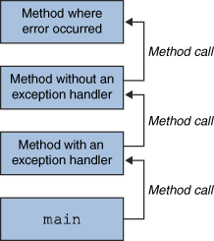
Figure 2-4 The call stack

The runtime system searches the call stack for a method that contains a block of code that can handle the exception. This block of code is called an exception handler. The search begins with the method in which the error occurred and proceeds through the call stack in the reverse order in which the methods were called. When an appropriate handler is found, the runtime system passes the exception to the handler. An exception handler is considered appropriate if the type of the exception object thrown matches the type that can be handled by the handler.
The exception handler chosen is said to catch the exception. If the runtime system exhaustively searches all the methods on the call stack without finding an appropriate exception handler, as shown in the next figure, the runtime system (and, consequently, the program) terminates.

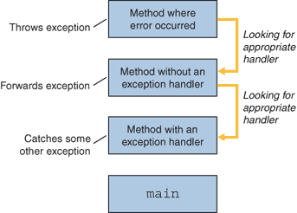
Figure 2-5 Searching the call stack for the exception handler

Using exceptions to manage errors has following advantages over traditional error-management techniques:
Separating Error-Handling Code from "Regular" Code
Propagating Errors Up the Call Stack
Grouping and Differentiating Error Types

A program can catch exceptions by using a combination of the try, catch, and finally blocks.
The try block identifies a block of code in which an exception can occur.
The catch block identifies a block of code, known as an exception handler that can handle a particular type of exception.
The finally block identifies a block of code that is guaranteed to execute, and is the right place to close files, recover resources, and otherwise clean up after the code enclosed in the try block.

Multithreading
Threads are called lightweight processes. Threads exist within a process — every process has at least one. Threads share the process's resources, including memory and open files. This makes for efficient, but potentially problematic, communication.

Multithreaded execution is an essential feature of the Java platform. Every application has at least one thread — or several, if you count "system" threads that do things like memory management and signal handling. But from the application programmer's point of view, you start with just one thread, called the main thread. This thread has the ability to create additional threads.
Each thread is associated with an instance of the class Thread. There are two basic strategies for using Thread objects to create a concurrent application.
To directly control thread creation and management, simply instantiate Thread each time the application needs to initiate an asynchronous task.
To abstract thread management from the rest of your application, pass the application's tasks to an executor.
An application that creates an instance of Thread must provide the code that will run in that thread. There are two ways to do this:
Provide a Runnable object- The Runnable interface defines a single method, run, meant to contain the code executed in the thread.
Subclass Thread- the Thread class itself implements Runnable, though its run method does nothing. An application can have subclass Thread, providing its own implementation of run.
The first way, which employs a Runnable object, is more general, because the Runnable objects can subclass a class other than Thread. The second way is easier to use in simple applications, but is limited by the fact that your task class must be a descendant of Thread.
The Thread class defines a number of methods useful for thread management. These include static methods, which provide information about, or affect the status of, the thread invoking the method. The other methods are invoked from other threads involved in managing the thread and Thread object.
Threads communicate primarily by sharing access to fields and the objects reference fields refer to. This form of communication is extremely efficient, but makes two kinds of errors possible: thread interference and memory consistency errors. The tool needed to prevent these errors is synchronization.

Collections Framework
A collection is simply an object that groups multiple elements into a single unit. Collections are used to store, retrieve, manipulate, and communicate aggregate data.
A collections framework is a unified architecture for representing and manipulating collections. All collections frameworks contain the following:
Interfaces: These are abstract data types that represent collections. Interfaces allow collections to be manipulated independently of the details of their representation.
Implementations: These are the concrete implementations of the collection interfaces. In essence, they are reusable data structures.
Algorithms: These are the methods that perform useful computations, such as searching and sorting, on objects that implement collection interfaces. The algorithms are said to be polymorphic: that is, the same method can be used on many different implementations of the appropriate collection interface. In essence, algorithms are reusable functionality.
The collections framework provides the following benefits:
Reduces programming effort
Increases program speed and quality
Allows interoperability among unrelated APIs
Reduces effort to learn and to use new APIs
Reduces effort to design new APIs
Fosters software reuse

The collections framework consists of:
Collection Interfaces - Represent different types of collections, such as sets, lists and maps. These interfaces form the basis of the framework.
General-Purpose Implementations - Primary implementations of the collection interfaces.
Legacy Implementations - The collection classes from earlier releases, Vector and Hash table, have been retrofitted to implement the collection interfaces.
Special-purpose Implementations - Implementations designed for use in special situations. These implementations display nonstandard performance characteristics, usage restrictions, or behavior.
Concurrent Implementations - Implementations designed for highly concurrent use.
Wrapper Implementations - Add functionality, such as synchronization, to other implementations.
Convenience Implementations - High-performance "mini-implementations" of the collection interfaces.
Abstract Implementations - Partial implementations of the collection interfaces to facilitate custom implementations.
Algorithms - Static methods that perform useful functions on collections, such as sorting a list.
Infrastructure - Interfaces that provide essential support for the collection interfaces.
Array Utilities - Utility functions for arrays of primitives and reference objects. Not, strictly speaking, a part of the Collections Framework, this functionality was added to the Java platform at the same time and relies on some of the same infrastructure
The general purpose implementations are summarized in the table below:
 |  | Implementations
 |  | Hash Table | Resizable Array | Balanced Tree
Interfaces | Set | HashSet |  | TreeSet
Interfaces | List |  | ArrayList
Interfaces | Map | HashMap |  | TreeMap
Table 2-1

JDBC
JDBC stands for "Java DataBase Connectivity". It is an API (Application Programming Interface) which consists of a set of Java classes, interfaces and exceptions and a specification to which both JDBC driver vendors and JDBC developers adhere when developing applications.
JDBC is a very popular data access standard. RDBMS (Relational Database Management Systems) or third-party vendors develop drivers which adhere to the JDBC specification. Other developers use these drivers to develop applications which access those databases.
The JDBC API is a Java API that can access any kind of tabular data, especially data stored in a Relational Database.
JDBC helps you to write java applications that manage these three programming activities:
Connect to a data source, like a database
Send queries and update statements to the database
Retrieve and process the results received from the database in answer to your query

JDBC Architecture
The JDBC API supports both two-tier and three-tier processing models for database access.

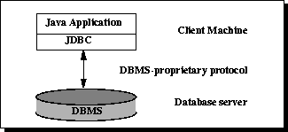
Figure 2-6 Two-tier Architecture for Data Access

In the two-tier model, a Java application talks directly to the data source. This requires a JDBC driver that can communicate with the particular data source being accessed. A user's commands are delivered to the database or other data source, and the results of those statements are sent back to the user. The data source may be located on another machine to which the user is connected via a network. This is referred to as a client/server configuration, with the user's machine as the client, and the machine housing the data source as the server.
In the three-tier model, commands are sent to a "middle tier" of services, which then sends the commands to the data source. The data source processes the commands and sends the results back to the middle tier, which then sends them to the user. MIS directors find the three-tier model very attractive because the middle tier makes it possible to maintain control over access and the kinds of updates that can be made to corporate data. Another advantage is that it simplifies the deployment of applications. Finally, in many cases, the three-tier architecture can provide performance advantages.

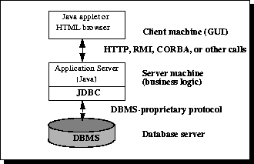
Figure 2-7 Three-tier Architecture for Data Access

Until recently, the middle tier has often been written in languages such as C or C++, which offer fast performance. However, with the introduction of optimizing compilers that translate Java bytecode into efficient machine-specific code and technologies such as Enterprise JavaBeans, the Java platform is fast becoming the standard platform for middle-tier development. This is a big plus, making it possible to take advantage of Java's robustness, multithreading, and security features.
With enterprises increasingly using the Java programming language for writing server code, the JDBC API is being used more and more in the middle tier of a three-tier architecture. Some of the features that make JDBC a server technology are its support for connection pooling, distributed transactions, and disconnected rowsets. The JDBC API is also what allows access to a data source from a Java middle tier.

Different database systems have surprisingly little in common: just a similar purpose and a mostly compatible query language. Beyond that, every database has its own API that you must learn to write programs that interact with the database. This has meant that writing code capable of interfacing with databases from more than one vendor has been a daunting challenge. Cross-database APIs exist, most notably Microsoft's ODBC API, but these tend to find themselves, at best, limited to a particular platform.
JDBC is Sun's attempt to create a platform-neutral interface between databases and Java. With JDBC, you can count on a standard set of database access features and (usually) a particular subset of SQL, SQL-92. The JDBC API defines a set of interfaces that encapsulate major database functionality, including running queries, processing results, and determining configuration information. A database vendor or third-party developer writes a JDBC driver, which is a set of classes that implements these interfaces for a particular database system. An application can use a number of drivers interchangeably. Following figure shows how an application uses JDBC to interact with one or more databases without knowing about the underlying driver implementations.

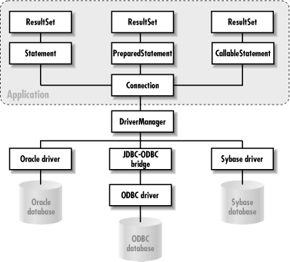

JDBC Components
JDBC includes four components:

- The JDBC API:
The JDBC API provides programmatic access to relational data from the Java programming language. Using the JDBC API, applications can execute SQL statements, retrieve results, and propagate changes back to an underlying data source. The JDBC API can also interact with multiple data sources in a distributed, heterogeneous environment.
The JDBC API is part of the Java platform, which includes the Java Standard Edition (Java SE ) and the Java Enterprise Edition (Java EE). The JDBC 4.0 API is divided into two packages: java.sql and javax.sql. Both packages are included in the Java SE and Java EE platforms.

- JDBC Driver Manager:
The JDBC DriverManager class defines objects which can connect Java applications to a JDBC driver. DriverManager has traditionally been the backbone of the JDBC architecture. It is quite small and simple.
The Standard Extension packages javax.naming and javax.sql let you use a DataSource object registered with a Java Naming and Directory Interface (JNDI) naming service to establish a connection with a data source. You can use either connecting mechanism, but using a DataSource object is recommended whenever possible.

- JDBC Test Suite:
The JDBC driver test suite helps you to determine that JDBC drivers will run your program. These tests are not comprehensive or exhaustive, but they do exercise many of the important features in the JDBC API.

- JDBC-ODBC Bridge:
The Java Software bridge provides JDBC access via ODBC drivers. Note that you need to load ODBC binary code onto each client machine that uses this driver. As a result, the ODBC driver is most appropriate on a corporate network where client installations are not a major problem, or for application server code written in Java in three-tier architecture.

JDBC Drivers
JDBC drivers are available for most database platforms, from a number of vendors and in a number of different flavors. There are four categories of drivers:

Type 1 JDBC-ODBC bridge drivers
Type 1 drivers use a bridge technology to connect a Java client to an ODBC database system. The JDBC-ODBC Bridge from Sun and InterSolv is the only existing example of a Type 1 driver. Type 1 drivers require some sort of non-Java software to be installed on the machine running your code, and they are implemented using native code.

Type 2 Native-API partly Java drivers
Type 2 drivers use a native code library to access a database, wrapping a thin layer of Java around the native library. For example, with Oracle databases, the native access might be through the Oracle Call Interface (OCI) libraries that were originally designed for C/C++ programmers. Type 2 drivers are implemented with native code, so they may perform better than all-Java drivers, but they also add an element of risk, as a defect in the native code can crash the Java Virtual Machine.

Type 3 Net-protocol All-Java drivers
Type 3 drivers define a generic network protocol that interfaces with a piece of custom middleware. The middleware component might use any other type of driver to provide the actual database access. BEA's WebLogic product line (formerly known as WebLogic Tengah and before that as jdbcKona/T3) is an example. These drivers are especially useful for applet deployment, since the actual JDBC classes can be written entirely in Java and downloaded by the client on the fly.

Type 4 Native-protocol All-Java drivers
Type 4 drivers are written entirely in Java. They understand database-specific networking protocols and can access the database directly without any additional software. These drivers are also well suited for applet programming, provided that the Java security manager allows TCP/IP connections to the database server.

Remote Method Invocation
Remote Method Invocation (RMI) facilitates object function calls between Java Virtual Machines (JVMs). JVMs can be located on separate computers - yet one JVM can invoke methods belonging to an object stored in another JVM. Methods can even pass objects that a foreign virtual machine has never encountered before, allowing dynamic loading of new classes as required.
The design goal for the RMI architecture was to create a Java distributed object model that integrates naturally into the Java programming language and the local object model.

RMI Architecture
The RMI architecture is based on one important principle: the definition of behavior and the implementation of that behavior are separate concepts. RMI allows the code that defines the behavior and the code that implements the behavior to remain separate and to run on separate JVMs.
This fits nicely with the needs of a distributed system where clients are concerned about the definition of a service and servers are focused on providing the service.
Specifically, in RMI, the definition of a remote service is coded using a Java interface. The implementation of the remote service is coded in a class. Therefore, the key to understanding RMI is to remember that interfaces define behavior and classes define implementation.
While the following diagram illustrates this separation,

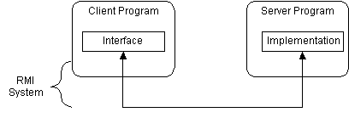
Figure 2-8 RMI System

RMI supports two classes that implement the same interface. The first class is the implementation of the behavior, and it runs on the server. The second class acts as a proxy for the remote service and it runs on the client. This is shown in the following diagram.
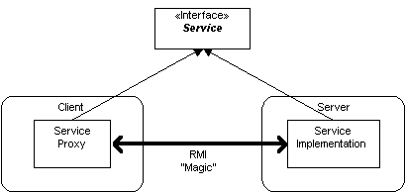
Figure 2-9 A client program makes method calls on the proxy object

A client program makes method calls on the proxy object, RMI sends the request to the remote JVM, and forwards it to the implementation. Any return values provided by the implementation are sent back to the proxy and then to the client's program.

RMI Architecture Layers
The RMI implementation is essentially built from three abstraction layers. The first is the Stub and Skeleton layer, which lies just beneath the view of the developer. This layer intercepts method calls made by the client to the interface reference variable and redirects these calls to a remote RMI service.
The next layer is the Remote Reference Layer. This layer understands how to interpret and manage references made from clients to the remote service objects. In JDK 1.1, this layer connects clients to remote service objects that are running and exported on a server. The connection is a one-to-one (unicast) link. In the Java 2 SDK, this layer was enhanced to support the activation of dormant remote service objects via Remote Object Activation.
The transport layer is based on TCP/IP connections between machines in a network. It provides basic connectivity, as well as some firewall penetration strategies.

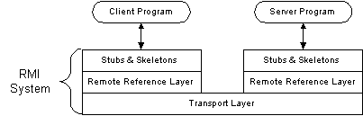
Figure 2-10 A layered architecture of RMI System

By using a layered architecture each of the layers could be enhanced or replaced without affecting the rest of the system. For example, the transport layer could be replaced by a UDP/IP layer without affecting the upper layers.

Using RMI
A working RMI system is composed of following parts:
- Interface definitions for the remote services
- Implementations of the remote services
- Stub and Skeleton files
- A server to host the remote services
- An RMI Naming service that allows clients to find the remote services
- A class file provider (an HTTP or FTP server)
- A client program that needs the remote services

software & other technologies

J2SE – Java 2 Standard Edition
There are two principal products in the Java SE platform family:
1) Java SE Runtime Environment (JRE)
2) Java Development Kit (JDK).
The Java Runtime Environment (JRE) provides the libraries, the Java Virtual Machine, and other components to run applets and applications written in the Java programming language. In addition, two key deployment technologies are part of the JRE: Java Plug-in, which enables applets to run in popular browsers; and Java Web Start, which deploys standalone applications over a network. It is also the foundation for the technologies in the Java 2 Platform, Enterprise Edition (J2EE) for enterprise software development and deployment. The JRE does not contain tools and utilities such as compilers or debuggers for developing applets and applications.
The Java Development Kit (JDK) is a superset of the JRE, and contains everything that is in the JRE, plus tools such as the compilers and debuggers necessary for developing applets and applications.

Java SE API
The Java SE application programming interface (API) defines the manner by which an applet or application can make requests to and use the functionality available in the compiled Java SE class libraries. (The Java SE class libraries are also part of the Java SE platform.)
The Java SE API consists of core technologies, Desktop (or client) technologies, and other technologies.
Core components provide essential functionality for writing powerful enterprise-worthy programs in key areas such as database access, security, remote method invocation (RMI), and communications.
Desktop components add a full range of features to help build applications that provide a rich user experience – deployment products such as Java Plug-in, component modeling APIs such as JavaBeans, and a graphical user interface. Other components round out the functionality.
Java Virtual Machine
The Java Virtual Machine is responsible for the hardware- and operating system-independence of the Java SE platform, the small size of compiled code (bytecodes), and platform security.

Java Platform Tools
The Java SE platform works with an array of tools, including Integrated Development Environments (IDEs), performance and testing tools, and performance monitoring tools.

J2EE – Java 2 Enterprise Edition
Java Platform, Enterprise Edition (Java EE) builds on the solid foundation of Java Platform, Standard Edition (Java SE) and is the industry standard for implementing enterprise-class service-oriented architecture (SOA) and next-generation web applications. The SDKs contain Sun GlassFish Enterprise Server, previously named Sun Java System Application Server, and provide support for Java EE 5 specifications.

Java Platform, Enterprise Edition (Java EE) is a set of coordinated technologies that significantly reduces the cost and complexity of developing, deploying, and managing multitier, server-centric applications. Building on the Java Platform, Standard Edition (Java SE), Java EE adds the capabilities that provide a complete, stable, secure, and fast Java platform for the enterprise.

Java Platform, Enterprise Edition 5 (Java EE 5) focuses on making development easier, yet retains the richness of the J2EE 1.4 platform. Offering new and updated features such as Enterprise JavaBeans (EJB) Technology 3.0, JavaServer Faces (JSF) Technology, and the latest web services APIs, Java EE 5 makes coding simpler and more straightforward, but maintains the power that has established Java EE as the premier platform for web services and enterprise application development.
The Java EE 5 SDK and Java Application Platform SDK provide support for Java EE 5 specifications, and the Java Application Platform SDK features additional runtimes such as Open ESB, Portlet Container, and Sun Java System Access Manager.

With a primary focus on ease of development, the Java EE 5 platform offers developers ready access to a secure, portable, and scalable platform for their enterprise applications. Java EE 5 technology makes coding simpler and more straightforward through the use of Java annotations, programming based on POJOs (Plain Old Java Objects), and resource injection concepts. Sun GlassFish Enterprise Server (formerly Sun Java System Application Server and hereafter referred to as Application Server) v2.1 supports all the technologies required by the Java EE 5 specification. A brief summary of the key Java EE 5 technologies is provided here.

Key technologies in Java EE 5 include the following:
Enterprise JavaBeans (EJB) 3.0
Java Persistence API 1.0
JavaServer Faces 1.2 Technology
Web Services Metadata for the Java Platform 1.0
Java API for XML-Based Web Services (JAX-WS) 2.0
Java Architecture for XML Binding (JAXB) 2.0
Streaming API for XML (StAX) 1.0

J2ME – Java 2 Micro Edition
J2ME stands for Java 2, Micro Edition. It is a stripped-down version of Java targeted at devices which have limited processing power and storage capabilities and intermittent or fairly low-bandwidth network connections. These include mobile phones, pagers, wireless devices and set-top boxes among others.
A Sample Wireless Stack would consist of:
Profiles
Configurations
Java Virtual Machines
Host Operating System

Web Components
Java web components are either servlets or pages created using JSP technology (JSP pages).
Servlets are Java programming language classes that dynamically process requests and construct responses.
JSP pages are text-based documents that execute as servlets but allow a more natural approach to creating static content.
The web tier might include a JavaBeans component to manage the user input and send that input to enterprise beans running in the business tier for processing, as shown:

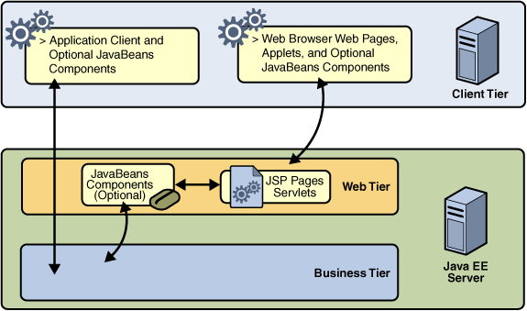
Figure 3-11 Java Web Components

Business Components
Business code, which is logic that solves or meets the needs of a particular business domain, is handled by enterprise beans running in the business tier.
Following figure shows how an enterprise bean receives data from client programs, processes it (if necessary), and sends it to the enterprise information system tier for storage. An enterprise bean also retrieves data from storage, processes it (if necessary), and sends it back to the client program:

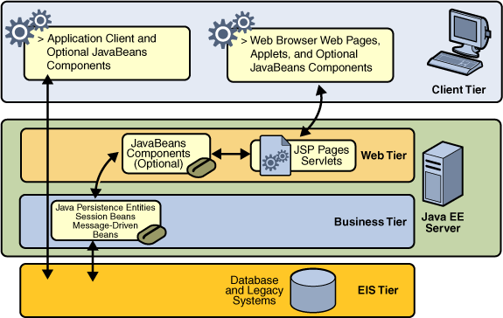
Figure 3-12 Java Business Components

Java EE 5 APIs
Following figure illustrates the availability of the Java EE 5 platform APIs in each Java EE container type. The following sections give a brief summary of the technologies required by the Java EE platform, and the APIs used in Java EE applications.

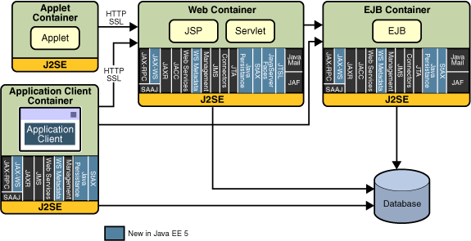
Figure 3-13 Java EE APIs

Enterprise JavaBeans Technology
An Enterprise JavaBeans (EJB) component, or enterprise bean, is a body of code having fields and methods to implement modules of business logic. You can think of an enterprise bean as a building block that can be used alone or with other enterprise beans to execute business logic on the Java EE server.
There are two kinds of enterprise beans: session beans and message-driven beans. A session bean represents a transient conversation with a client. When the client finishes executing, the session bean and its data are gone. A message-driven bean combines features of a session bean and a message listener, allowing a business component to receive messages asynchronously. Commonly, these are Java Message Service (JMS) messages.
In Java EE 5, entity beans have been replaced by Java persistence API entities. An entity represents persistent data stored in one row of a database table. If the client terminates, or if the server shuts down, the persistence manager ensures that the entity data is saved.

Java Servlet Technology
Java servlet technology lets you define HTTP-specific servlet classes. A servlet class extends the capabilities of servers that host applications that are accessed by way of a request-response programming model. Although servlets can respond to any type of request, they are commonly used to extend the applications hosted by web servers.

JavaServer Pages Technology
JavaServer Pages (JSP) technology lets you put snippets of servlet code directly into a text-based document. A JSP page is a text-based document that contains two types of text: static data (which can be expressed in any text-based format such as HTML, WML, and XML) and JSP elements, which determine how the page constructs dynamic content.

JavaServer Pages Standard Tag Library
The JavaServer Pages Standard Tag Library (JSTL) encapsulates core functionality common to many JSP applications. Instead of mixing tags from numerous vendors in your JSP applications, you employ a single, standard set of tags. This standardization allows you to deploy your applications on any JSP container that supports JSTL and makes it more likely that the implementation of the tags is optimized.
JSTL has iterator and conditional tags for handling flow control, tags for manipulating XML documents, internationalization tags, tags for accessing databases using SQL, and commonly used functions.

Java Message Service API
The Java Message Service (JMS) API is a messaging standard that allows Java EE application components to create, send, receive, and read messages. It enables distributed communication that is loosely coupled, reliable, and asynchronous.

JavaMail API
Java EE applications use the JavaMail API to send email notifications. The JavaMail API has two parts: an application-level interface used by the application components to send mail, and a service provider interface. The Java EE platform includes JavaMail with a service provider that allows application components to send Internet mail.

Java Database Connectivity API
The Java Database Connectivity (JDBC) API lets you invoke SQL commands from Java programming language methods. You use the JDBC API in an enterprise bean when you have a session bean access the database. You can also use the JDBC API from a servlet or a JSP page to access the database directly without going through an enterprise bean.
The JDBC API has two parts: an application-level interface used by the application components to access a database, and a service provider interface to attach a JDBC driver to the Java EE platform.

NetBeans
A free, open-source Integrated Development Environment for software developers.
One can get all the tools you need to create professional desktop, enterprise, web, and mobile applications with the Java language, C/C++, and even dynamic languages such as PHP, JavaScript, Groovy, and Ruby.
NetBeans IDE is easy to install and use straight out of the box and runs on many platforms including Windows, Linux, Mac OS X and Solaris.

NetBeans IDE is an integrated development environment (IDE) for writing, compiling, testing, and debugging desktop applications and web applications for the Java platform.
NetBeans IDE includes a full-featured text editor with syntax highlighting and error checking, visual design tools, Ant support, version control system support, and many other features.

The NetBeans IDE 6.5 provides several new features and enhancements, such as rich PHP, JavaScript and Ajax editing features, improved support for using the Hibernate web framework and the Java Persistence API, and tighter GlassFish v3 and MySQL integration.

NetBeans – Developing Windows Application
NetBeans can be used to create professional-looking GUIs with automatic spacing and alignment.

- Professional Swing GUI Building
Design Swing GUIs by dragging and positioning GUI components from a palette onto a canvas. The GUI builder automatically takes care of the correct spacing and alignment. Click into JLabels, JButtons, ButtonGroups, JTrees, JTextFields, ComboBoxes and edit their properties directly in place. You can use the GUI builder to prototype GUIs right in front of customers.

- Intuitive and Customizable
You can choose whether the GUI code should be generated with fully qualified or simple class names. The help bar displays context-sensitive hints about what can be done with the selected component and suggests shortcuts that can speed up your work in the future. The NetBeans IDE also comes with built-in support for GUI localization and accessibility. If you use JDK 6 Update 10, you can now preview your forms in the new Nimbus look and feel.

- Standard and Custom GUI Components
The extensible Component Palette comes with pre-installed Swing and AWT components and includes a visual menu designer. Use the Component Inspector to view a component's tree and properties.

- Swing Application Framework (JSR 296) Support
The Swing Application Framework simplifies the handling of the application life cycle, actions and resources. Take advantage of the provided code-generation tools and building blocks, and develop small to medium-sized desktop applications faster than ever. Create menus fast and intuitively by dragging and dropping menu items onto the canvas; you can add mnemonics and rename menu items inline by clicking and typing in the Design view.

- Beans Binding technology (JSR 295) Support
Take advantage of Beans Binding technology and the Java Persistence API to create Swing desktop database applications more easily. Using the new Java Desktop Application project template, you can quickly set up a form that displays a database table and also enables you to modify the database. Bind a database table to an existing form by dragging a table from the Runtime window onto the form.

NetBeans – Developing Web Application, Enterprise Application and Web Service
Netbean can be used to write standards-based web and enterprise applications that can be accessed with a web browser over the internet or an intranet.

- Web and Enterprise Application Development
The NetBeans IDE provides tools for building all Java EE components, including web pages, servlets, web services, and Enterprise Java Beans (EJBs).

- Web Frameworks
The NetBeans IDE make it easy to create Java EE projects that rely on the Spring and Hibernate frameworks. The editor supports code completion, navigation and refactoring for mapping files.

- Easy Migration from Eclipse
You can import Eclipse Web Application projects. Imported Eclipse projects stay synchronized with their original when you modify them in Eclipse.

- Multi-Language Editor Support
Take advantage of full syntax highlighting, code completion, pop-up documentation, and error checking for JSP, JSF, XML, JavaScript, CSS and PHP - even mixed.

GlassFish
GlassFish is an enterprise-quality Java EE 5 application server that offers advanced clustering, centralized administration, and best-in-class performance built by the GlassFish community. The Java EE SDKs contain Sun GlassFish Enterprise Server, previously named Sun Java System Application Server.
Key Features of Sun GlassFish Enterprise Server :
It complies fully with the latest Java EE 5 specification to deliver one of the best application runtimes for next-generation enterprise applications and web services. It implements and extends the following Java EE standards:
- Enterprise Java Beans 3.0
- JAXB 2.0
- Java Persistence
- Java Server Faces 1.2
- Java Server Pages 2.1 (JSP 2.1)
- Java Server Pages Standard Tag Library (JSTL) 1.2
- Streaming API for XML (StAX)
- Web Services Metadata
- Java API for XML based Web Services 2.0 (JAX-WS 2.0)
- Common Annotations for the Java Platform 1.0 (CAJ 1.0)

Apache Tomcat
Apache Tomcat powers numerous large-scale, mission-critical web applications across a diverse range of industries and organizations.

Apache Tomcat is developed in an open and participatory environment and released under the Apache Software License. Apache Tomcat is intended to be a collaboration of the best-of-breed developers from around the world.
Apache Tomcat is an implementation of the Java Servlet and JavaServer Pages technologies.
Apache Tomcat version 6.0 implements the Servlet 2.5 and JavaServer Pages 2.1

Tomcat 6.0 is designed to run on JSE 5.0 and later. A standard installation of Tomcat 6.0 makes all of the following APIs available for use by web applications (by placing them in "lib"):
* annotations-api.jar (Annotations package)
* catalina.jar (Tomcat Catalina implementation)
* catalina-ant.jar (Tomcat Catalina Ant tasks)
* catalina-ha.jar (High availability package)
* catalina-tribes.jar (Group communication)
* el-api.jar (EL 2.1 API)
* jasper.jar (Jasper 2 Compiler and Runtime)
* jasper-el.jar (Jasper 2 EL implementation)
* jasper-jdt.jar (Eclipse JDT 3.3 Java compiler)
* jsp-api.jar (JSP 2.1 API)
* servlet-api.jar (Servlet 2.5 API)
* tomcat-coyote.jar (Tomcat connectors and utility classes)
* tomcat-dbcp.jar (package renamed database connection pool based on Commons DBCP)

One can make additional APIs available to all of your web applications by putting unpacked classes into a "classes" directory (not created by default), or by placing them in JAR files in the "lib" directory.

MySQL Database Server
MySQL, the most popular Open Source SQL database server, is developed, distributed, and supported by MySQL AB, now purchased by Sun MicroSystem.
The official way to pronounce “MySQL” is “My Ess Que Ell” (not “my sequel”).

Following are main features of MySQL:
- MySQL is a database management system.
A database is a structured collection of data. It may be anything from a simple shopping list to a picture gallery or the vast amounts of information in a corporate network. To add, access, and process data stored in a computer database, you need a database management system such as MySQL Server. Since computers are very good at handling large amounts of data, database management systems play a central role in computing, as standalone utilities or as parts of other applications.

- MySQL is a relational database management system.
A relational database stores data in separate tables rather than putting all the data in one big storeroom. This adds speed and flexibility. The SQL part of “MySQL” stands for “Structured Query Language.” SQL is the most common standardized language used to access databases and is defined by the ANSI/ISO SQL Standard. The SQL standard has been evolving since 1986 and several versions exist. In this manual, “SQL-92” refers to the standard released in 1992, “SQL:1999” refers to the standard released in 1999, and “SQL:2003” refers to the current version of the standard. We use the phrase “the SQL standard” to mean the current version of the SQL Standard at any time.

- MySQL software is Open Source.
Open Source means that it is possible for anyone to use and modify the software. Anybody can download the MySQL software from the Internet and use it without paying anything.

- The MySQL Database Server is very fast, reliable, and easy to use.
MySQL Server was originally developed to handle large databases much faster than existing solutions and has been successfully used in highly demanding production environments for several years. Although under constant development, MySQL Server today offers a rich and useful set of functions. Its connectivity, speed, and security make MySQL Server highly suited for accessing databases on the Internet.
- MySQL Server works in client/server or embedded systems.
The MySQL Database Software is a client/server system that consists of a multi-threaded SQL server that supports different backends, several different client programs and libraries, administrative tools, and a wide range of application programming interfaces (APIs).

- A large amount of contributed MySQL software is available.
It is very likely that your favorite application or language supports the MySQL Database Server.

web interface

HTML
HTML is a language for describing web pages.
- HTML stands for Hyper Text Markup Language
- HTML is not a programming language, it is a markup language
- A markup language is a set of markup tags
- HTML uses markup tags to describe web pages

HTML markup tags are usually called HTML tags
- HTML tags are keywords surrounded by angle brackets like <html>
- HTML tags normally come in pairs like <b> and </b>
- The first tag in a pair is the start tag, the second tag is the end tag
- Start and end tags are also called opening tags and closing tags.

HTML Documents
- HTML documents describe web pages
- HTML documents contain HTML tags and plain text
- HTML documents are also called web pages

The purpose of a web browser (like Internet Explorer or Firefox) is to read HTML documents and display them as web pages. The browser does not display the HTML tags, but uses the tags to interpret the content of the page.

XML
A few words about XML
XML
- stands for Extensible Markup Language
- is a markup language much like HTML
- was designed to carry data, not to display data
- tags are not predefined. You must define your own tags
- is designed to be self-descriptive
- is a W3C Recommendation

Purpose of using XML
XML is used in many aspects of web development, often to simplify data storage and sharing.
XML
- separates data from html
- simplifies data sharing
- simplifies data transport
- simplifies platform changes
- makes your data more available

Syntax of using XML
- All XML Elements Must Have a Closing Tag
- XML Tags are Case Sensitive
- XML Elements Must be Properly Nested
- XML Documents Must Have a Root Element
- XML Attribute Values Must be Quoted

XHTML
XHTML is a combination of HTML and XML (EXtensible Markup Language). It consists of all the elements in HTML 4.01, combined with the strict syntax of XML.

XHTML
- stands for Extensible Hypertext Markup Language
- is almost identical to HTML 4.01
- is a stricter and cleaner version of HTML
- is HTML defined as an XML application
- is a W3C Recommendation

Syntax of using XML:
- XHTML elements must be properly nested
- XHTML elements must always be closed
- XHTML elements must be in lowercase
- XHTML documents must have one root element
- Attribute names must be in lower case
- Attribute values must be quoted
- Attribute minimization is forbidden
- The id attribute replaces the name attribute
- The XHTML DTD defines mandatory elements

CSS
A few words about CSS:
- CSS stands for Cascading Style Sheets
- Styles define how to display HTML elements
- Styles are normally stored in Style Sheets
- Styles were added to HTML 4.0 to solve a problem
- External Style Sheets can save you a lot of work
- External Style Sheets are stored in CSS files
- Multiple style definitions will cascade into one

CSS provides means to customize inbuilt HTML tags
HTML tags were originally designed to define the content of a document. They were supposed to say "This is a header", "This is a paragraph", "This is a table", by using tags like <h1>, <p>, <table>, and so on. The layout of the document was supposed to be taken care of by the browser, without using any formatting tags.
As the two major browsers - Netscape and Internet Explorer - continued to add new HTML tags and attributes (like the <font> tag and the color attribute) to the original HTML specification, it became more and more difficult to create Web sites where the content of HTML documents was clearly separated from the document's presentation layout.
To solve this problem, the World Wide Web Consortium (W3C) - the non profit, standard setting consortium, responsible for standardizing HTML - created STYLES in addition to HTML 4.0.
All major browsers support Cascading Style Sheets.
Styles sheets define HOW HTML elements are to be displayed, just like the font tag and the color attribute in HTML 3.2. Styles are normally saved in external .css files. External style sheets enable you to change the appearance and layout of all the pages in your Web, just by editing one single CSS document!

Multiple Styles Will Cascade Into One
Style sheets allow style information to be specified in many ways. Styles can be specified inside a single HTML element, inside the <head> element of an HTML page, or in an external CSS file. Even multiple external style sheets can be referenced inside a single HTML document.
Generally speaking we can say that all the styles will "cascade" into a new "virtual" style sheet by the following rules, where number four has the highest priority:
Browser default
External style sheet
Internal style sheet (inside the <head> tag)
Inline style (inside an HTML element)
So, an inline style (inside an HTML element) has the highest priority, which means that it will override a style declared inside the <head> tag, in an external style sheet, or in a browser (a default value).
If the external style sheet link is placed below the internal style sheet in HTML <head>, the external style sheet will override the internal style sheet.

JavaScript
JavaScript is used in millions of Web pages to improve the design, validate forms, detect browsers, create cookies, and much more. JavaScript is the most popular scripting language on the internet, and works in all major browsers, such as Internet Explorer, Firefox, and Opera.

A few words about JavaScript
- JavaScript was designed to add interactivity to HTML pages
- JavaScript is a scripting language
- A scripting language is a lightweight programming language
- JavaScript is usually embedded directly into HTML pages
- JavaScript is an interpreted language (means that scripts execute without preliminary compilation)
- Everyone can use JavaScript without purchasing a license

Purpose of using JavaScript
- JavaScript gives HTML designers a programming tool - HTML authors are normally not programmers, but JavaScript is a scripting language with a very simple syntax! Almost anyone can put small "snippets" of code into their HTML pages
- JavaScript can put dynamic text into an HTML page - A JavaScript statement like this: document. write("<h1>" + name + "</h1>") can write a variable text into an HTML page
- JavaScript can react to events - A JavaScript can be set to execute when something happens, like when a page has finished loading or when a user clicks on an HTML element
- JavaScript can read and write HTML elements - A JavaScript can read and change the content of an HTML element
- JavaScript can be used to validate data - A JavaScript can be used to validate form data before it is submitted to a server. This saves the server from extra processing
- JavaScript can be used to detect the visitor's browser - A JavaScript can be used to detect the visitor's browser, and - depending on the browser - load another page specifically designed for that browser

software life cycle model

The software life cycle model (also called process model) is a descriptive and diagrammatic representation of the software life cycle. A life cycle model represents all the activities required to make a software product transit through its life cycle phases. It also captures the order in which these activities are to be undertaken. In other words, a life cycle model maps the different activities performed on a software product from its inception to retirement. Different life cycle models may map the basic development activities to phases in different ways. During any life cycle phase, more than one activity may also be carried out.

Different phases of the classical waterfall model
The classical waterfall model is intuitively the most obvious way to develop software. Though the classical waterfall model is elegant and intuitively obvious, it is not a practical model in the sense that it cannot be used in actual software development projects. Thus, this model can be considered to be a theoretical way of developing software. But all other life cycle models are essentially derived from the classical waterfall model. So, in order to be able to appreciate other life cycle models it is necessary to learn the classical waterfall model.
Classical waterfall model divides the life cycle into the following phases:
- Feasibility Study
- Requirements Analysis and Specification
- Design
- Coding and Unit Testing
- Integration and System Testing
- Maintenance
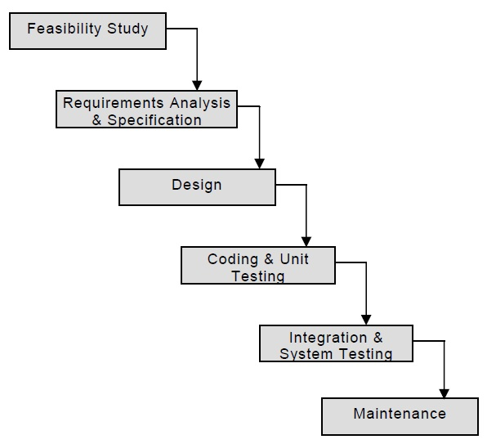
Figure 5-14 Waterfall Model

Feasibility Study
The main aim of feasibility study is to determine whether it would be financially and technically feasible to develop the product.
- At first project managers or team leaders try to have a rough understanding of what is required to be done by visiting the client side. They study different input data to the system and output data to be produced by the system. They study what kind of processing is needed to be done on these data and they look at the various constraints on the behavior of the system.
- After they have an overall understanding of the problem they investigate the different solutions that are possible. Then they examine each of the solutions in terms of what kind of resources required, what would be the cost of development and what would be the development time for each solution.
- Based on this analysis they pick the best solution and determine whether the solution is feasible financially and technically. They check whether the customer budget would meet the cost of the product and whether they have sufficient technical expertise in the area of development.

Requirements Analysis and Specification
The aim of the requirements analysis and specification phase is to understand the exact requirements of the customer and to document them properly. This phase consists of two distinct activities, namely
- Requirements gathering and analysis, and
- Requirements specification

The goal of the requirements gathering activity is to collect all relevant information from the customer regarding the product to be developed. This is done to clearly understand the customer requirements so that incompleteness and inconsistencies are removed.

The requirements analysis activity is begun by collecting all relevant data regarding the product to be developed from the users of the product and from the customer through interviews and discussions.

The data collected from such a group of users usually contain several contradictions and ambiguities, since each user typically has only a partial and incomplete view of the system. Therefore it is necessary to identify all ambiguities and contradictions in the requirements and resolve them through further discussions with the customer. After all ambiguities, inconsistencies, and incompleteness have been resolved and all the requirements properly understood, the requirements specification activity can start. During this activity, the user requirements are systematically organized into a Software Requirements Specification (SRS) document.

The customer requirements identified during the requirements gathering and analysis activity are organized into a SRS document. The important components of this document are functional requirements, the nonfunctional requirements, and the goals of implementation.

Design
The goal of the design phase is to transform the requirements specified in the SRS document into a structure that is suitable for implementation in some programming language. In technical terms, during the design phase the software architecture is derived from the SRS document. Two distinctly different approaches are available: the traditional design approach and the object-oriented design approach.

- Traditional design approach
Traditional design consists of two different activities; first a structured analysis of the requirements specification is carried out where the detailed structure of the problem is examined. This is followed by a structured design activity. During structured design, the results of structured analysis are transformed into the software design.

- Object-oriented design approach
In this technique, various objects that occur in the problem domain and the solution domain are first identified, and the different relationships that exist among these objects are identified. The object structure is further refined to obtain the detailed design.

Coding and Unit Testing
The purpose of the coding and unit testing phase (sometimes called the implementation phase) of software development is to translate the software design into source code. Each component of the design is implemented as a program module. The end-product of this phase is a set of program modules that have been individually tested.
During this phase, each module is unit tested to determine the correct working of all the individual modules.

Integration and System Testing
Integration of different modules is undertaken once they have been coded and unit tested. During the integration and system testing phase, the modules are integrated in a planned manner. The different modules making up a software product are almost never integrated in one shot. Integration is normally carried out incrementally over a number of steps. During each integration step, the partially integrated system is tested and a set of previously planned modules are added to it. Finally, when all the modules have been successfully integrated and tested, system testing is carried out. The goal of system testing is to ensure that the developed system conforms to its requirements laid out in the SRS document. System testing usually consists of three different kinds of testing activities:
- α – testing: It is the system testing performed by the development team.
- β – testing: It is the system testing performed by a friendly set of customers.
- acceptance testing: It is the system testing performed by the customer himself after the product delivery to determine whether to accept or reject the delivered product.

System testing is normally carried out in a planned manner according to the system test plan document. The system test plan identifies all testing-related activities that must be performed, specifies the schedule of testing, and allocates resources. It also lists all the test cases and the expected outputs for each test case.

Maintenance
Maintenance of a typical software product requires much more than the effort necessary to develop the product itself. Maintenance involves performing any one or more of the following three kinds of activities:
- Correcting errors that were not discovered during the product development phase. This is called corrective maintenance.
- Improving the implementation of the system, and enhancing the functionalities of the system according to the customer’s requirements. This is called perfective maintenance.
- Porting the software to work in a new environment. For example, porting may be required to get the software to work on a new computer platform or with a new operating system. This is called adaptive maintenance.

Project WebDrive Explorer

Software Requirement Specification

Overview
Definitions
User: User is a person who will use the application according to the rights assigned to him.
WebDriveExplorer: A web based environment using which a user can browse his/her files on server machine from any browser. A user will be able to download and upload his/her files on a central location on using internet.

Overview
WebDriveExplorer will provide an online environment to the users using which users will be able to browse his data saved on a drive on the server machine.
Users will be able to upload and download a file from the server machine

WebDriveExplorer will allow a user to place or remove a file on the server machine. User will be able to rename a folder and also he will be able to create new folders on the drive.

All the operations such as upload/download file, add/remove folders etc will be done by users according to the rights assigned to them

The various features of the WebDriveExplorer are:
- It provides space on internet to create folders and files.
- It helps in sharing data in the form of files stored on the internet.
- Data can be easily uploaded and downloaded using WebDriveExplorer.
- It is secure as access to WebDriveExplorer will be given to users having a username and password.
- Data on WebDrive can be accessed from anywhere as iWebDriveExplorer can be accessed from any machine having internet.

Current System
In the current system user has to store his/her files on the local system as no provision to store files on the central system are available. Even if there is a provision to store files on central system, one has to connect to the central system using manual connection to network. In the current system if user has the connection rights to the central system then he/she can access all the folders and files of that particular system, instead of selected ones.

In the current system user can access the files, create, and delete folders from within the local network only. No provision of accessing the drive from internet is available in the current system.

Limitations of the current system:

- There is no centralization of data of users.
- User cannot access his/her files from a remote machine using internet.
- No provision to upload a file to a central system using browsers.
- No Provision to download files from a central system using browser.
- In current system even if user can access a central system in a local network to copy files, it is not secure as user has access to folders and files of other users on the that system. Using WebDriveExplorer a user will not have a direct access to central machine and all the access to his files and folders will be through browser.

Business Functions Provided in Proposed System
- Login: Users of the system would be required to login into the system. After authentication user would be able to login into the system and use the functionality for which he would be authorized.
- Maintain User Account: Users of the system would be able to edit/update their account details.
- Download/Upload file: Using this, users will be able to upload and download file from server. All the functionality to manage uploading and downloading files will be achieved by this business function.
- DriveExplorer: Using this business function support to browse the data on server will be developed. All users will be able to manage their folders, files on the server machine.
- ShareManager : Using this business function users will be able to share their files and folders with other users.
- Generate Reports: System will be able to generate various reports required by users.

Input Requirements of the System
- Login Details
- User Details
- Input files
- Information of user rights
- Details of drive space allocation to users

Output Requirements of the System
- A web based environment using which user would be able to browse his/her data on server machine.
- Functionality to upload and download file on server machine.
- Reports

Special User Requirements
- Automatic Email Generation to the concerned person
- Sharing of resources between users.

Modules
- Admin Module: Admin module is the central module of the system. This module will allow admin users to configure the system with required information like roles of users, their access rights. This module will be used by admin to manage all the users of WebDriveExplorer.

- Registered User Module: All the functionality required for registered user such as managing profile, managing files and folders , sharing files and folders, will be achieved in this module.

- Uploader Module: This module will allow users to upload files to the central system using WebDriveExplorer. This module will be accessible to users.

- Downloader Module: This module will allow users to download files from the central system using WebDriveExplorer.

Users of the System
The different users of the system are:
- Administrator: Administrator is the super user of the application. Administrator will manage different users of the application and their access rights.Space allocation on WebDrive to users will also be managed by the administrator.
- User: These are the registered users of the application. Each users will have a space on the server where they will be able to upload files and also they will be able to download files from the allocated space.Users will also be able to share files and folders. They will be able to perform the tasks according to the rights assigned by the administrator.

Technologies to be used
- Java is Platform Independent, Secure, Object Oriented, Scalable, and Robust Programming Language.
It consists of two parts:
- JVM stands for Java Virtual Machine, which is run time environment to execute the java programs.
- Java API (Application Programming Interface) that consists of inbuilt classes used in java programs.

- JDBC
JDBC (Java Database Connectivity) is an API, which is used for the communication of java programs with different databases.

- Java Mail API
The JavaMail API provides a platform-independent and protocol-independent framework to build mail and messaging applications.

- Servlets
Servlets are basically a part of Java Platform, Enterprise Edition (Java EE) and is a technology that is used for extending the functionality of the servers that host application access via request-response programming model.

- JSP
JSP (Java Server Pages) a technology of Java Platform, Enterprise Edition (Java EE) is used for server-side programming and with the help of JSP we can segregate the work of a web designer and a developer.

- JasperReports
JasperReports is an open source reporting engine. Using JasperReports reports can generated in any type of application i.e. console application, desktop application, web application, enterprise application.

- MySQL
MySQL is used as database, used to store data. It is RDBMS.

- Scripting Languages
- HTML & CSS
- JavaScript
- XML, XHTML
- AJAX

- Others
- UML
- Ant – Used for deployment
- JUnit – Unit Testing.

Software Requirements
- JDK 1.6 - NetBeans 6.5.1
- Database - MySQL Database Server 5.0
- Reports - JasperReports 3.7.6
- Web Server - Tomcat 6.0.18
- Application Server - GlassFish v2.1
- Testing Tool - JUnit 4.5
- Deployment Tool - Ant 1.7
- Operating System - Windows 7 / Vista / XP sp3 / Linux Fedora

Hardware Requirements
- Intel P4 processor with minimum 2.0Ghz Speed
- RAM: Minimum 512MB
- Hard Disk: Minimum 20GB

Data Model

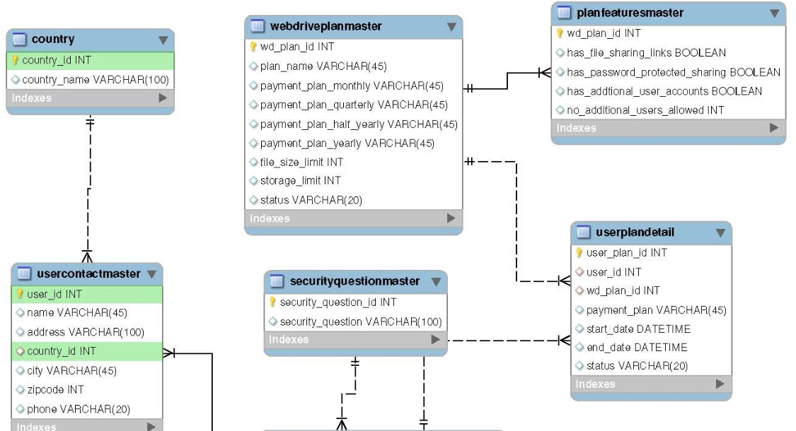

Figure 6-15 Data Model (Part 1)

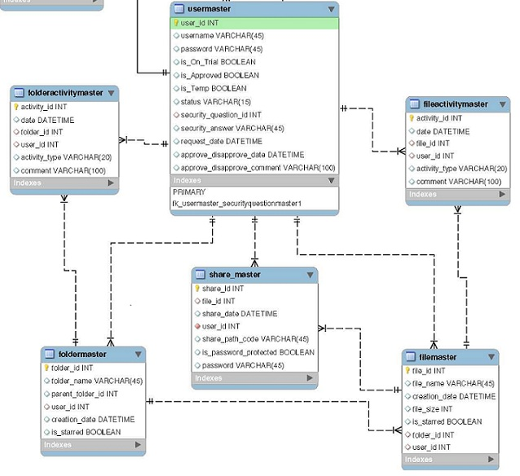
Figure 6-16 Data Model (Part 2)

Data Flow Diagrams

Trail Request Maintenance

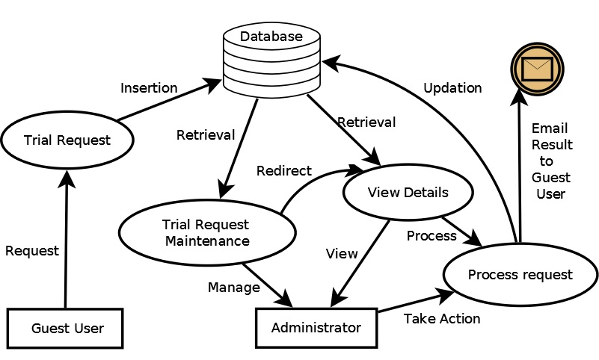
Figure 6-17 Trail Request Maintenance

Approve User on Trial

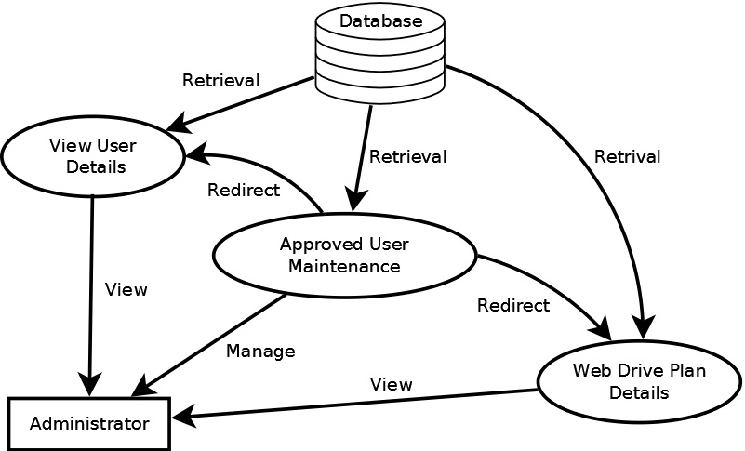
Figure 6-18 Approve User on Trial

Web Drive Plan Maintenance

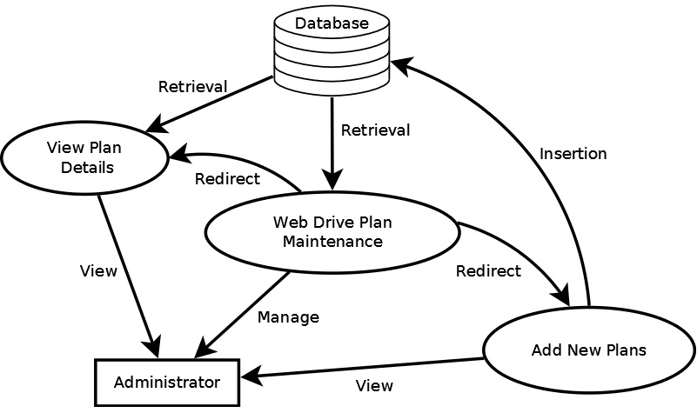
Figure 6-19 Web Drive Plan Maintenance

Profile Management

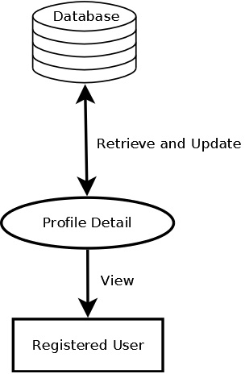
Figure 6-20 Profile Management

Manage Web Drive

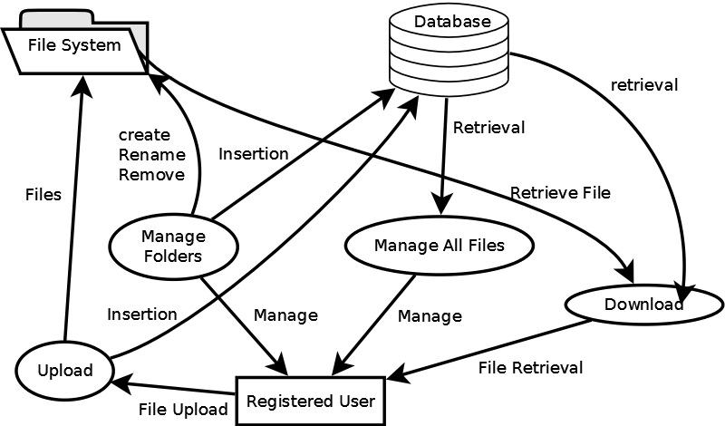
Figure 6-21 Manage Web Drive

Share Files

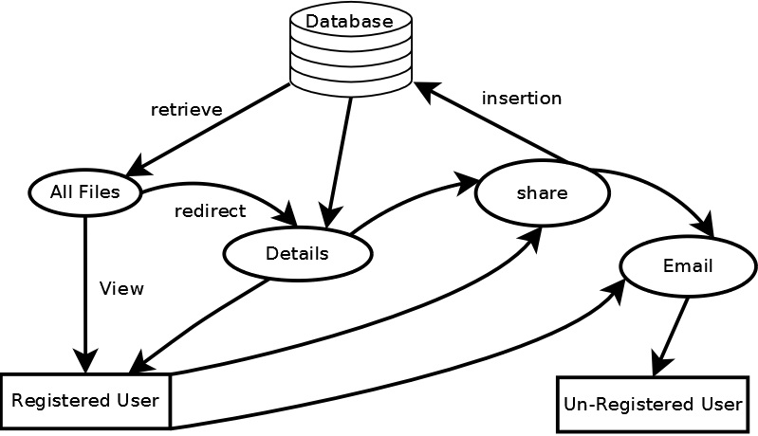
Figure 6-22 Share Files

View Shared Files

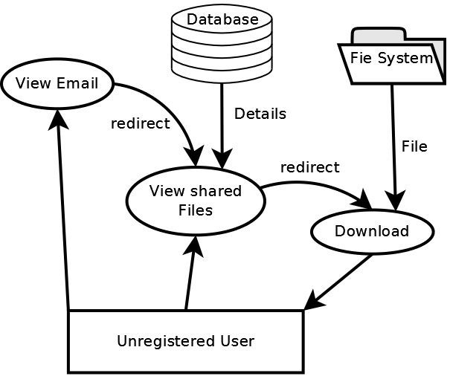
Figure 6-23 View Shared Files

Screen Layouts

Login

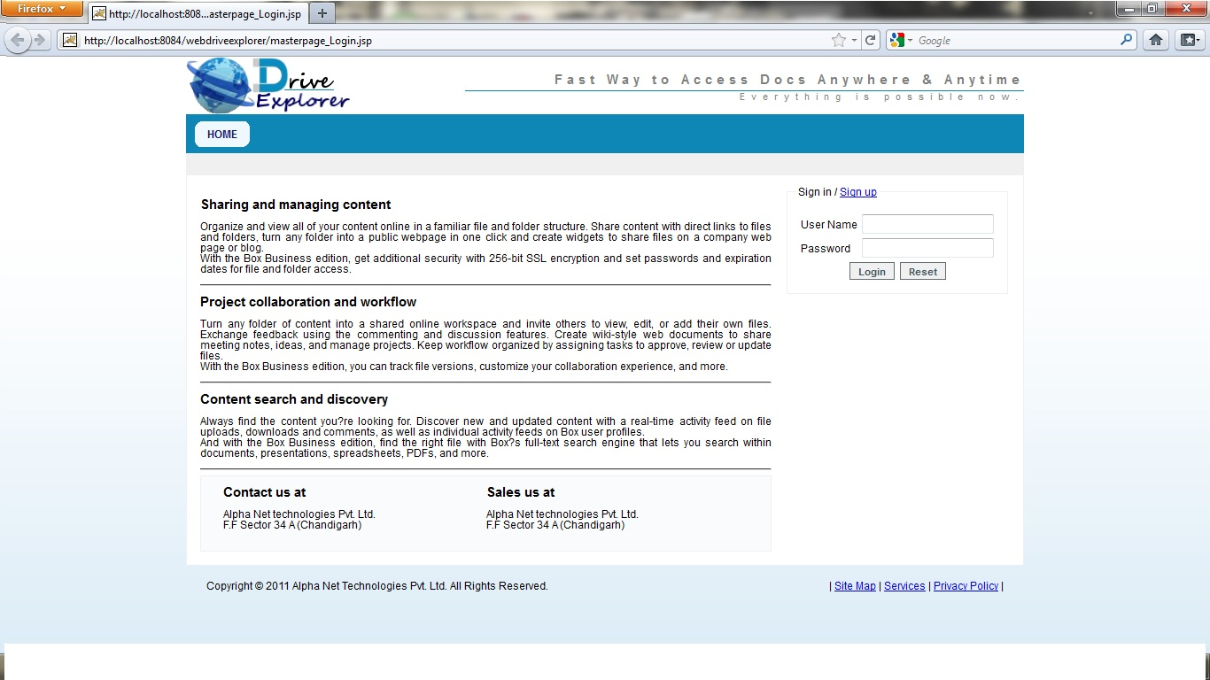

Manage WebDrive Plan

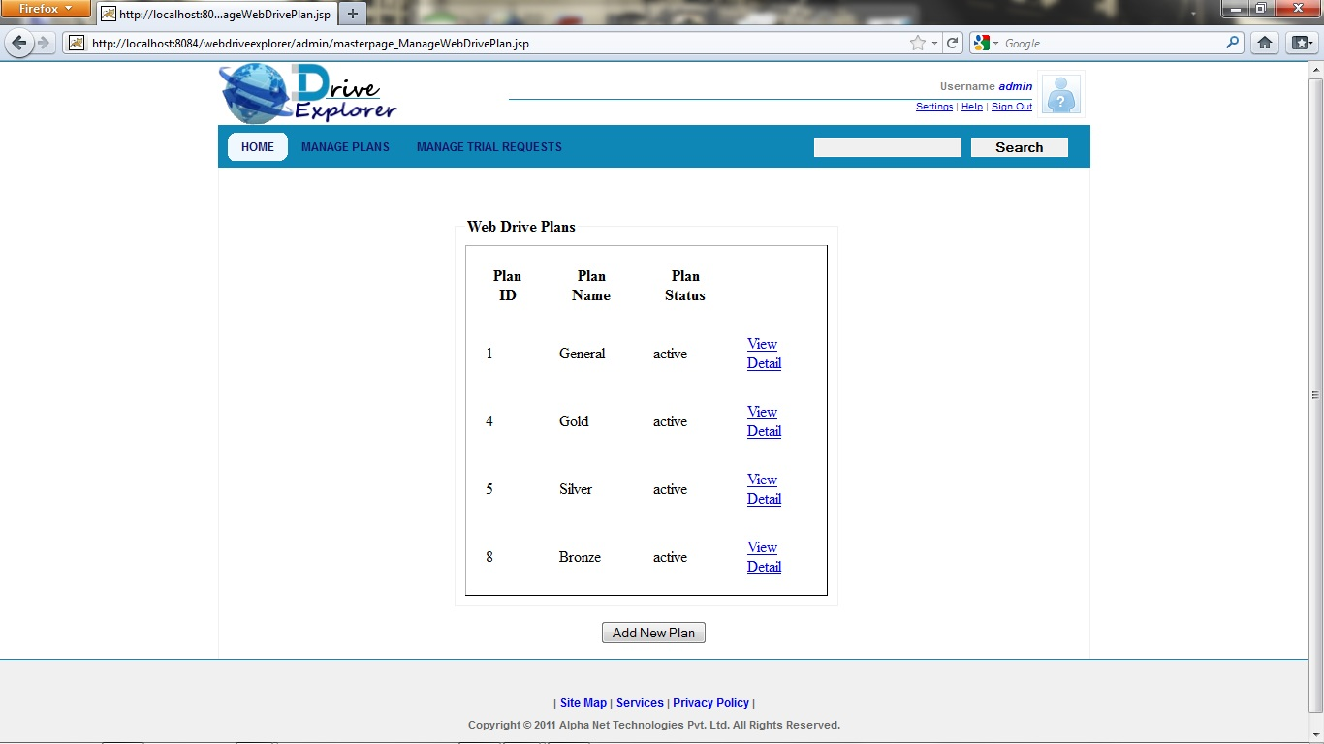

Trial Request Maintenance

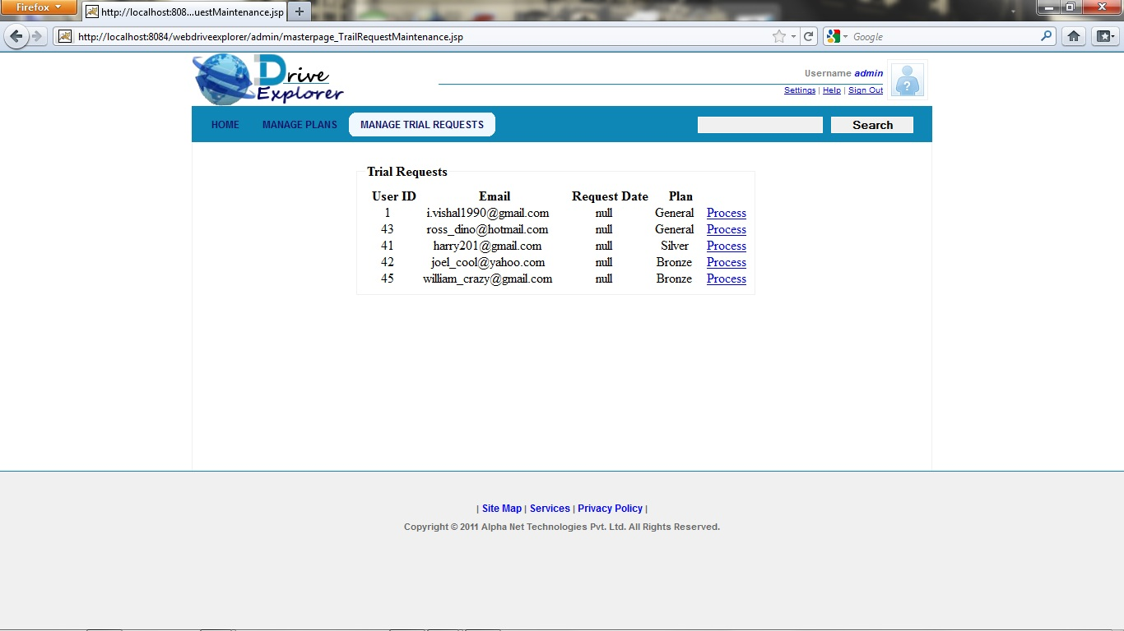

Manage All Files

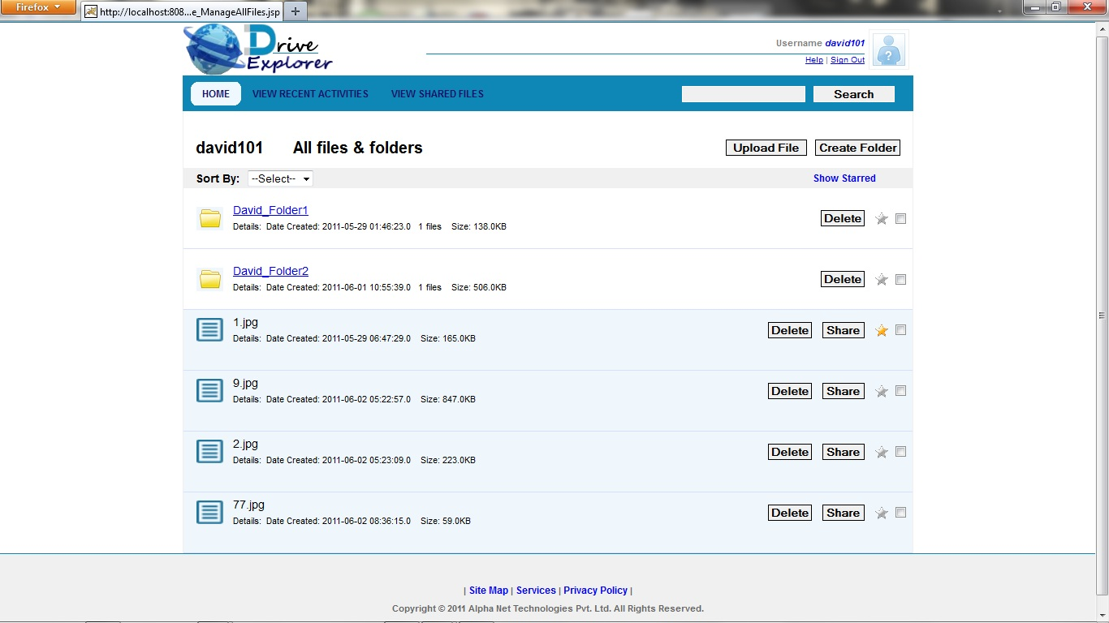

View Recent Activities

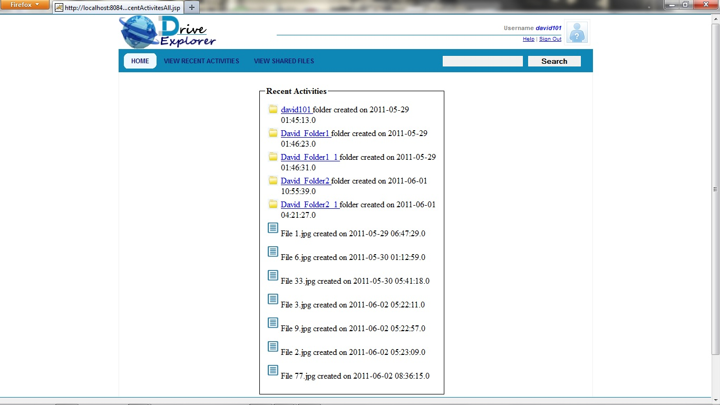

Upload File

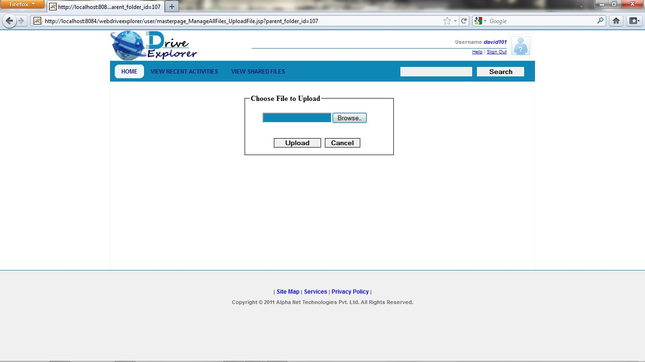

Create Folder

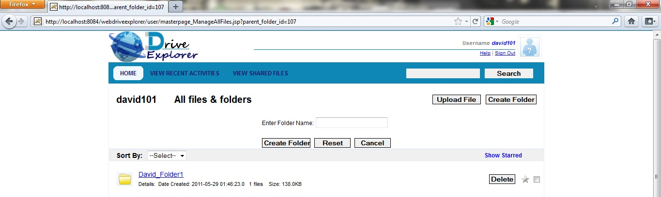

Share Files

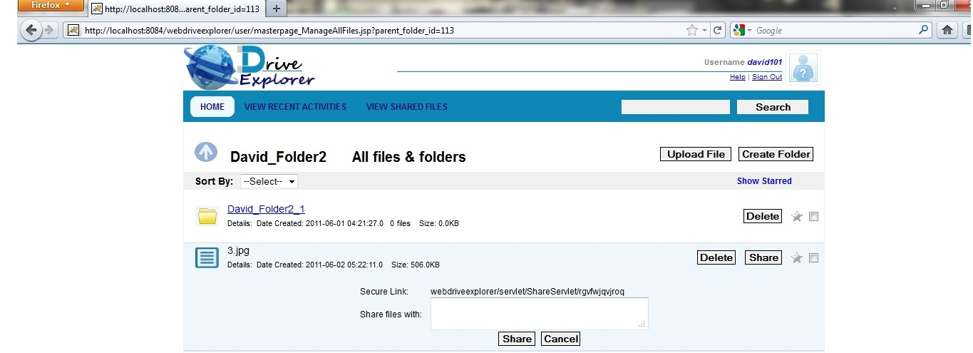

Show Starred Files

